**Assignment 2.2**

**Task 3**

Create a file max-temp.txt in local FS.

**vi max-temp.txt** 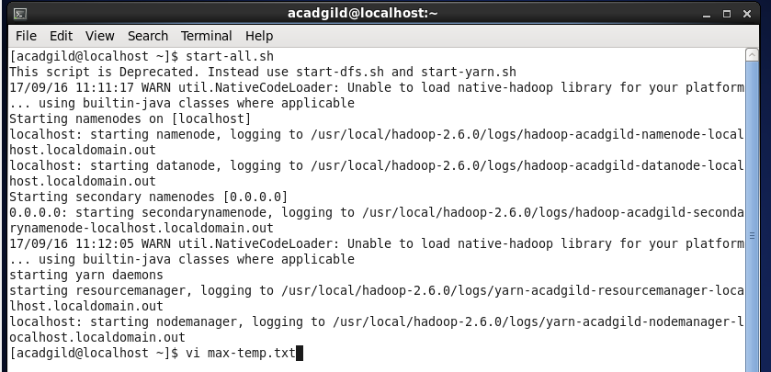

Put some 10-15 records of date and temperature example:

dd-mm-yyyy,temperature

Example:

10-01-1990,10

10-02-1991,20

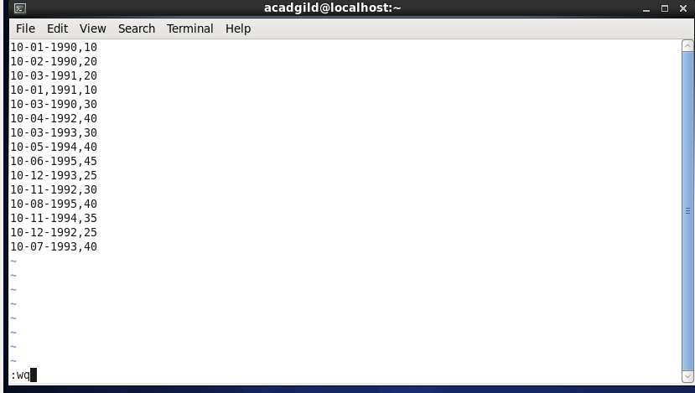

Move this file to HDFS at /user/acadgild/hadoop.

**hadoop fs -put max-temp.txt /user /user/acadgild/hadoop/**

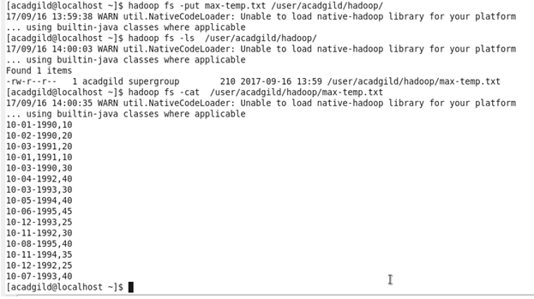

**Task 4**

Change the permission of the file /user/acadgild/hadoop/max-temp.txt, such that

only the owner and the group members have full control over the file.

Others do not have any control over it.

**hadoop fs -chmod 770 /user/acadgild/hadoop/max-temp.txt**

